Infographi:

<https://medilux5.wordpress.com/2023/09/02/infographic/>

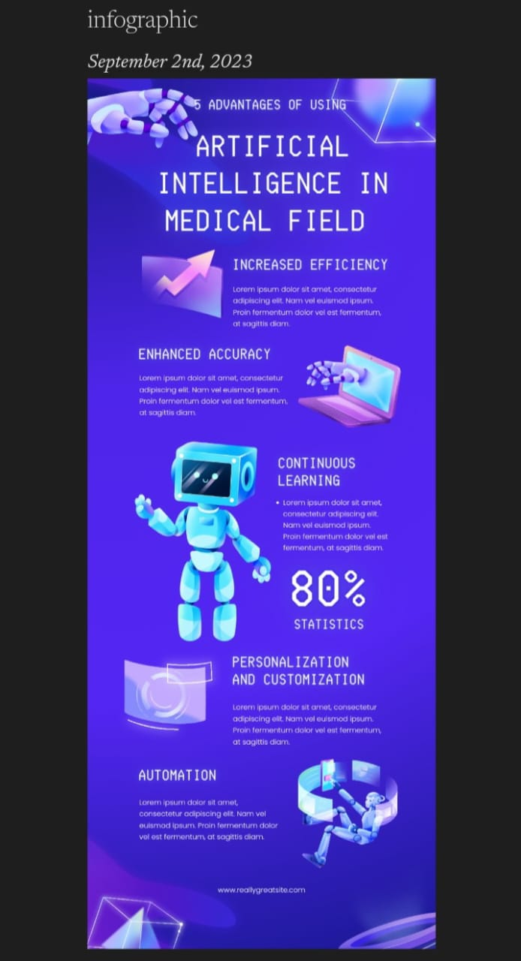

News letter:

<https://medilux5.wordpress.com/2023/09/02/email-news-letter/>

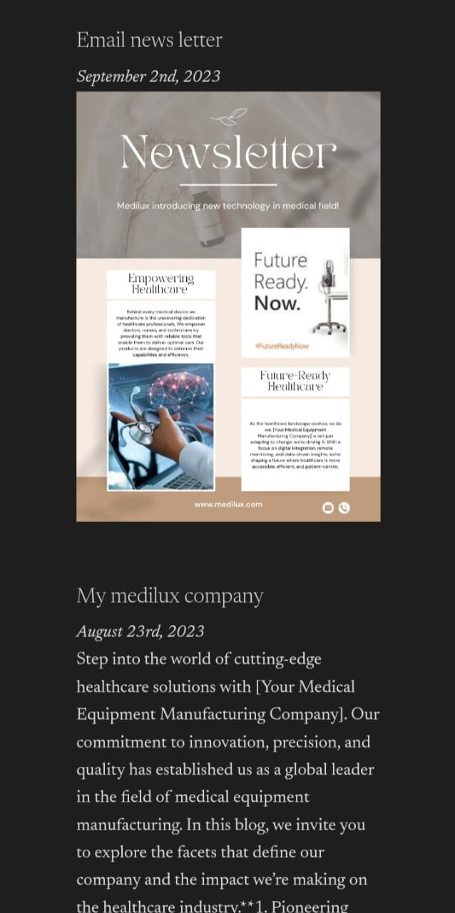

Blog:

<http://medilux5.wordpress.com>

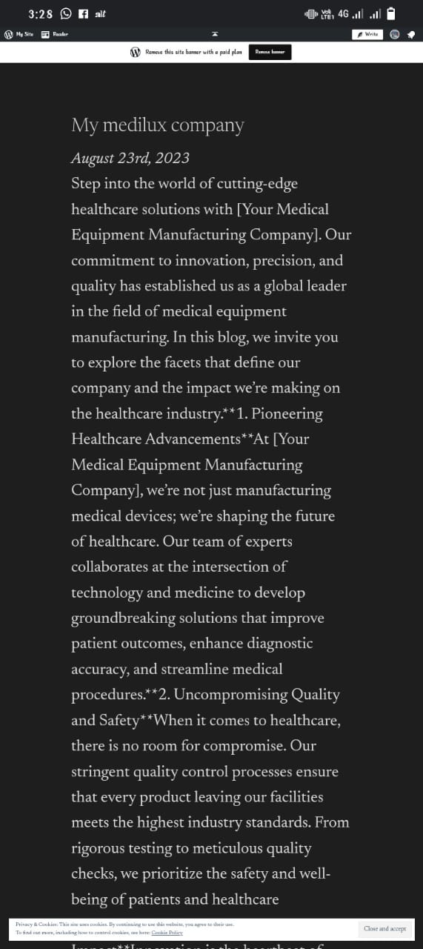

Facebook:

<https://www.facebook.com/profile.php?id=61550617160927&mibextid=9R9pXO>

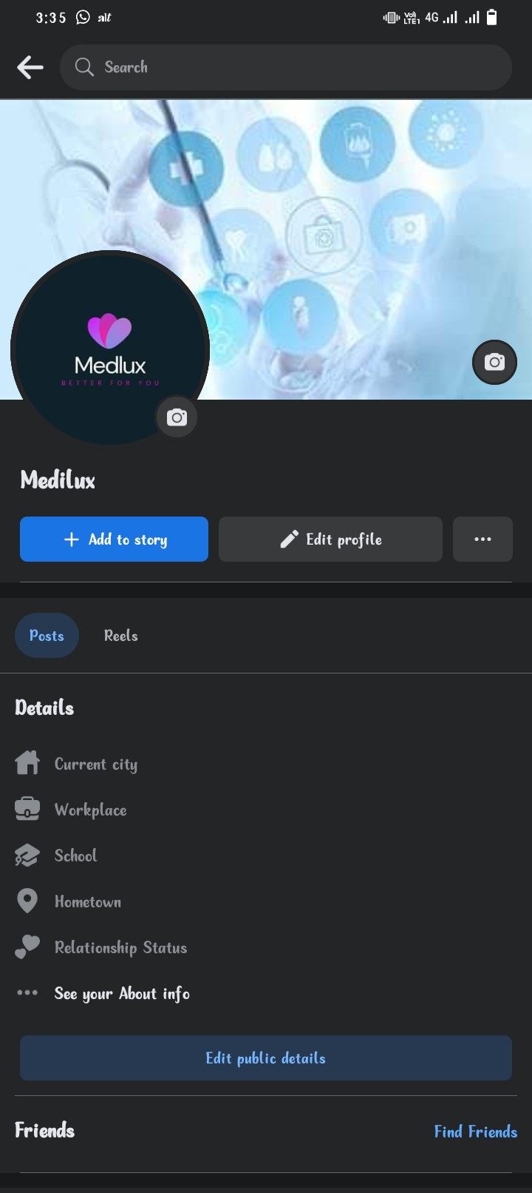

Facebook post:

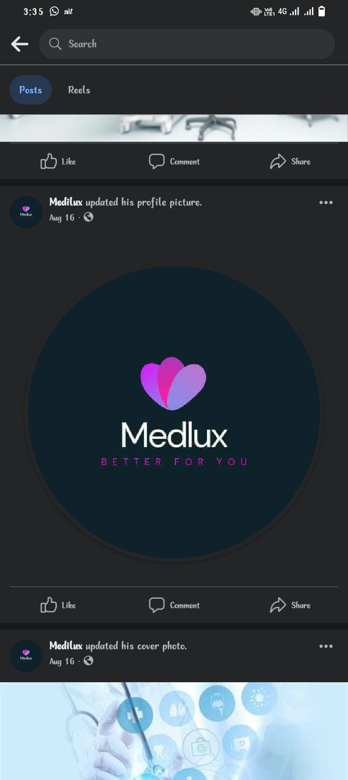

Facebook Post:

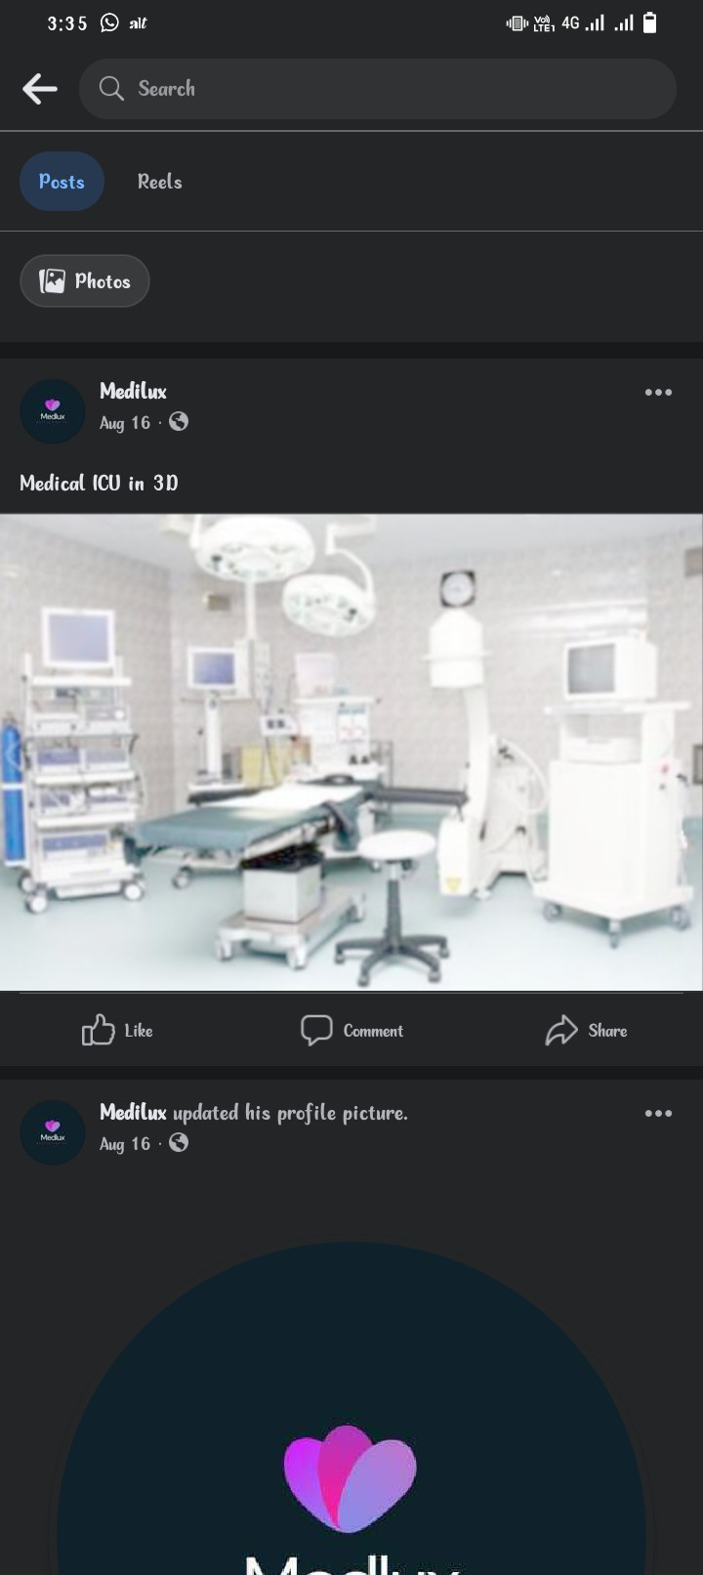

Linkden:

<https://www.linkedin.com/in/mani-kandan-72bb89288?utm_source=share&utm_campaign=share_via&utm_content=profile&utm_medium=android_app>

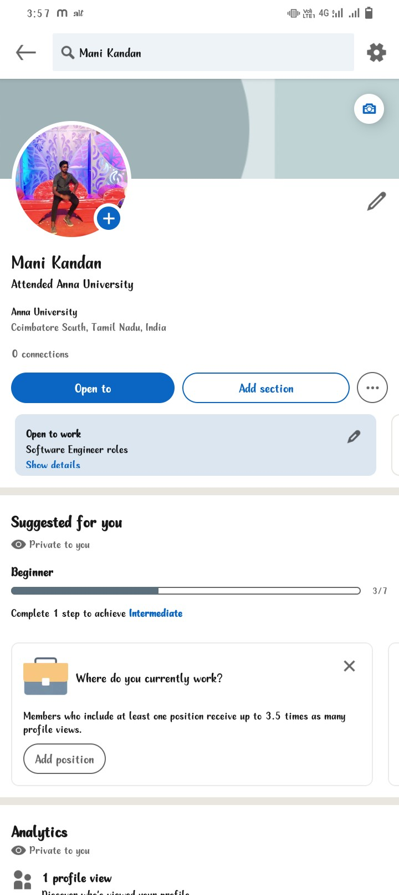

Analytics : <https://analytics.google.com/analytics/web/?authuser=0#/p406747506/reports/intelligenthome>

